**Creating Microservices for account and loan**

In this hands on exercises, we will create two microservices for a bank. One microservice for handing accounts and one for handling loans. Each microservice will be a specific independent Spring RESTful Webservice maven project having it's own pom.xml.

The only difference is that, instead of having both account and loan as a single application, it is split into two different applications. These webservices will be a simple service without any backend connectivity.

**SOLUTION:  
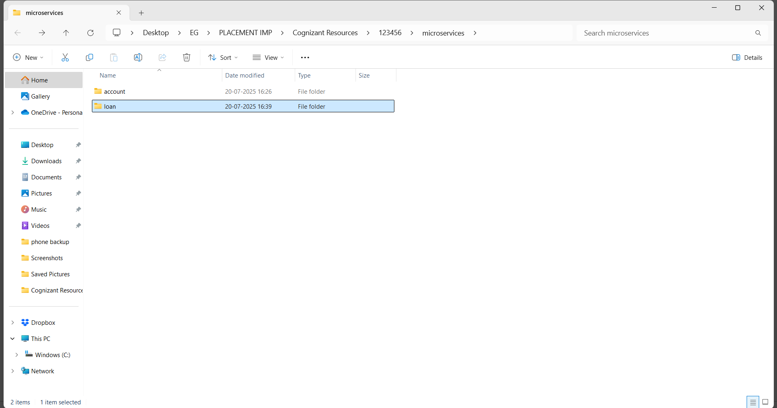  
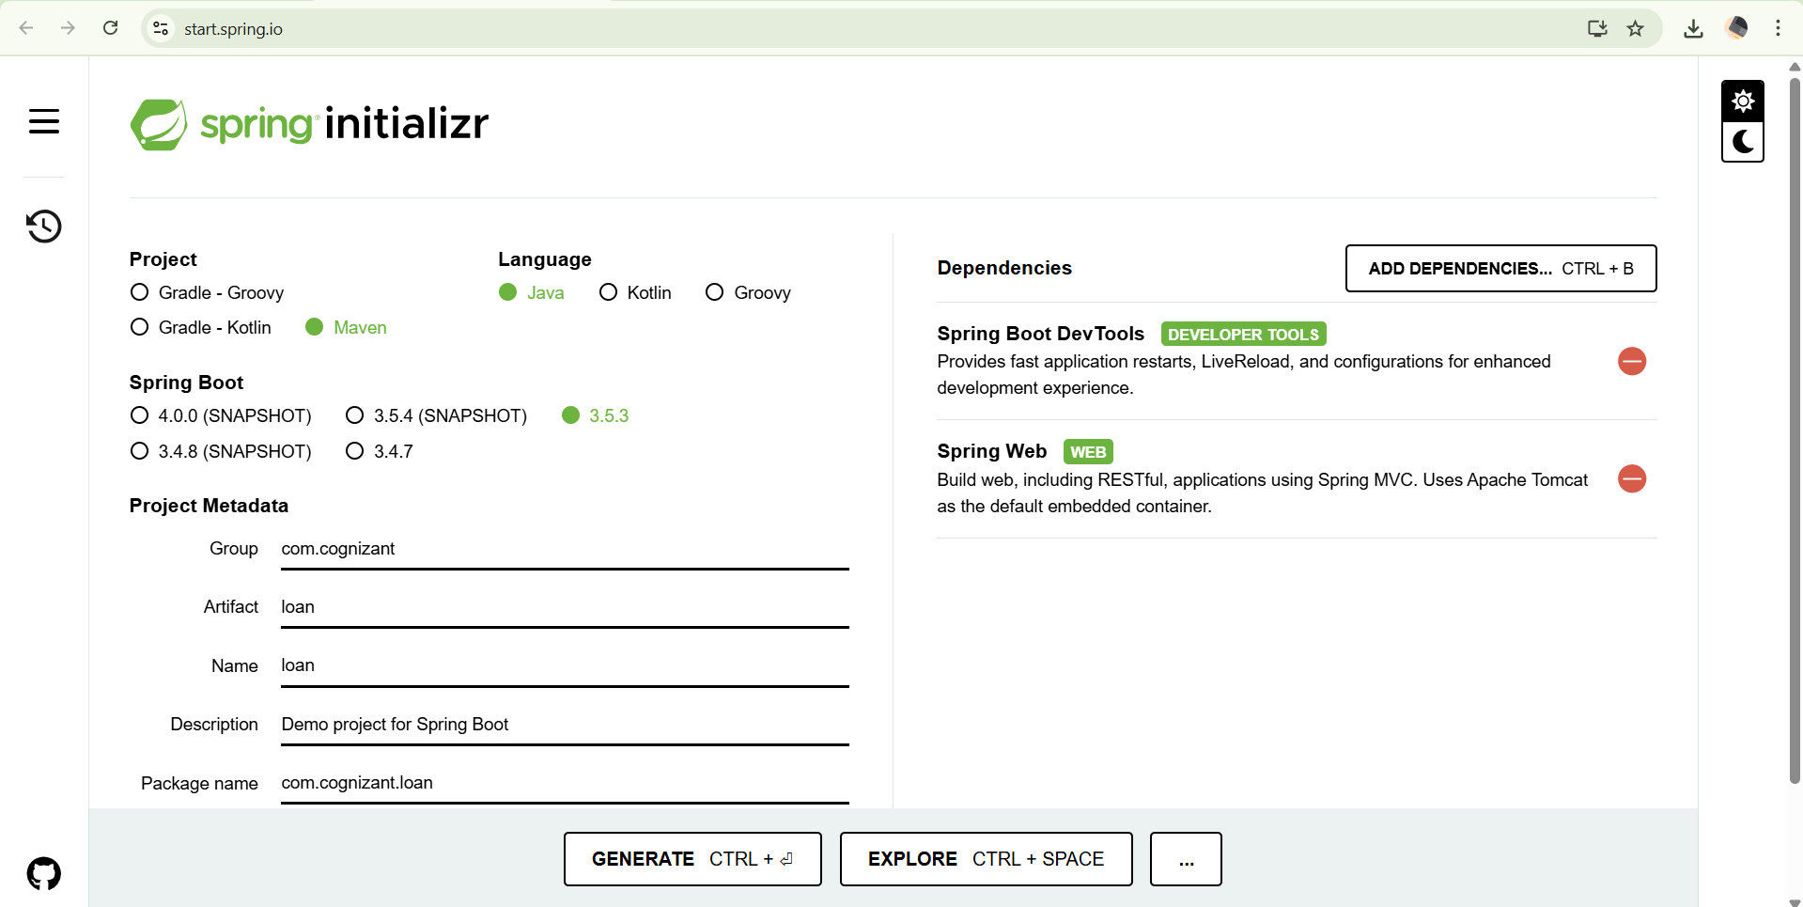**

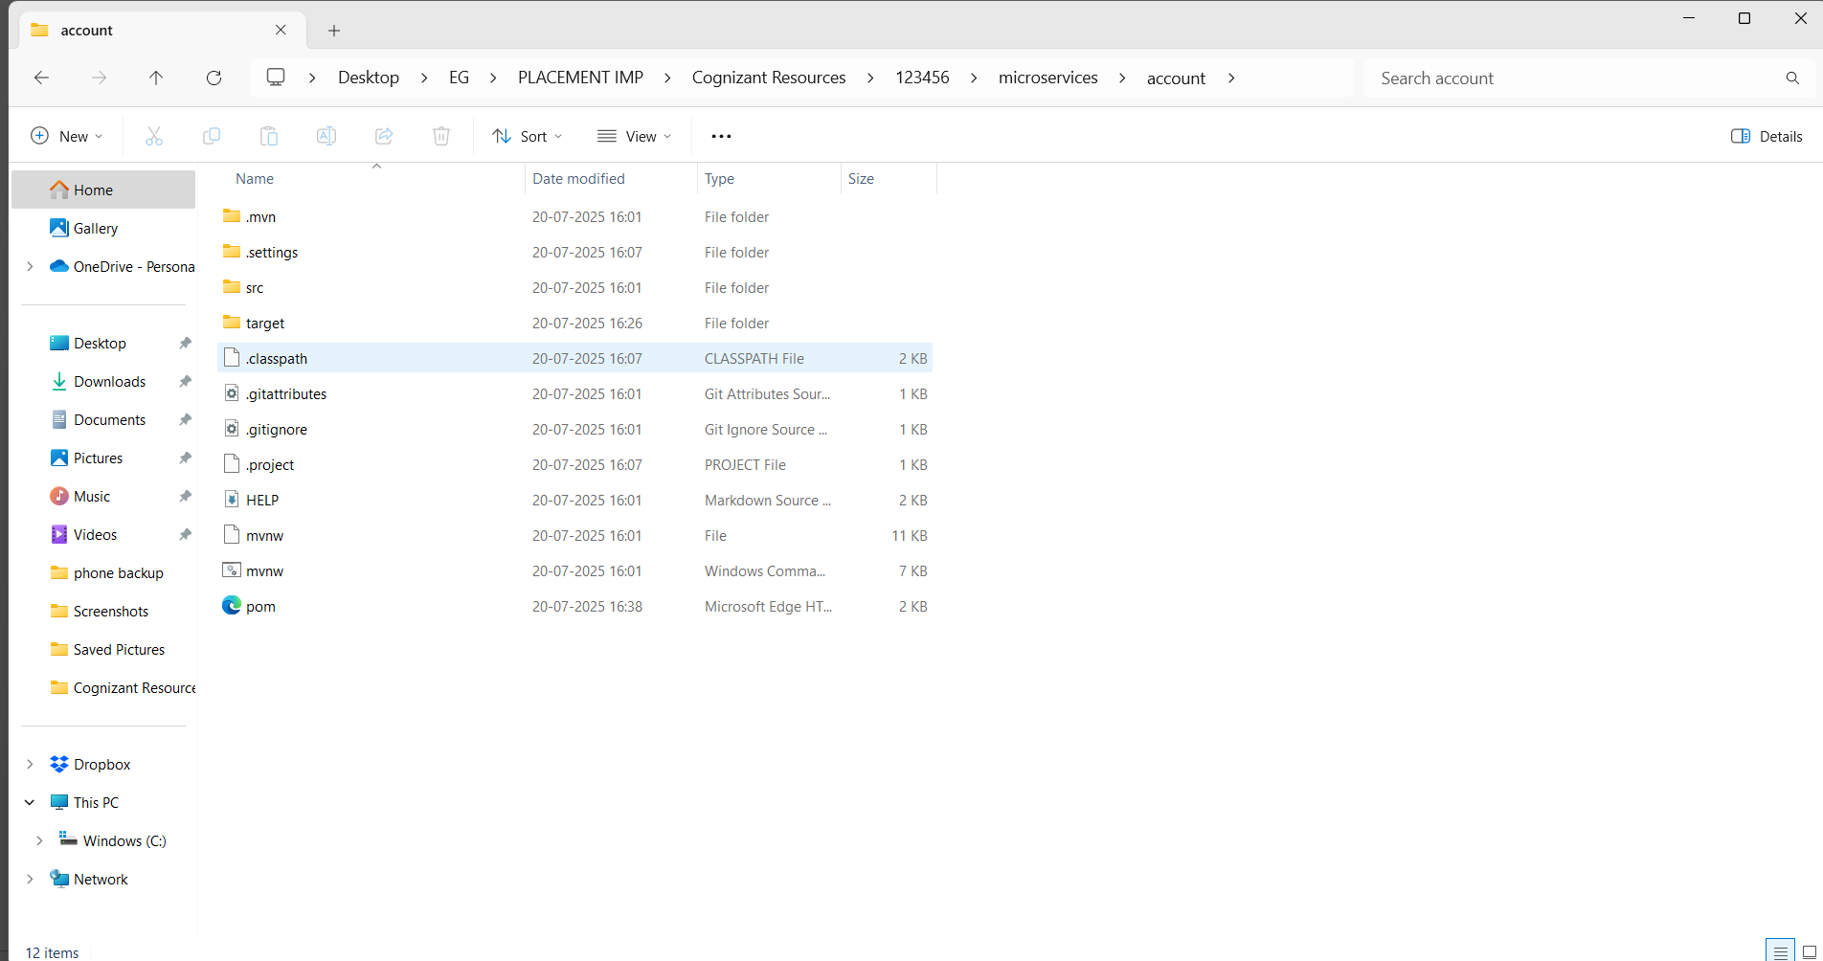

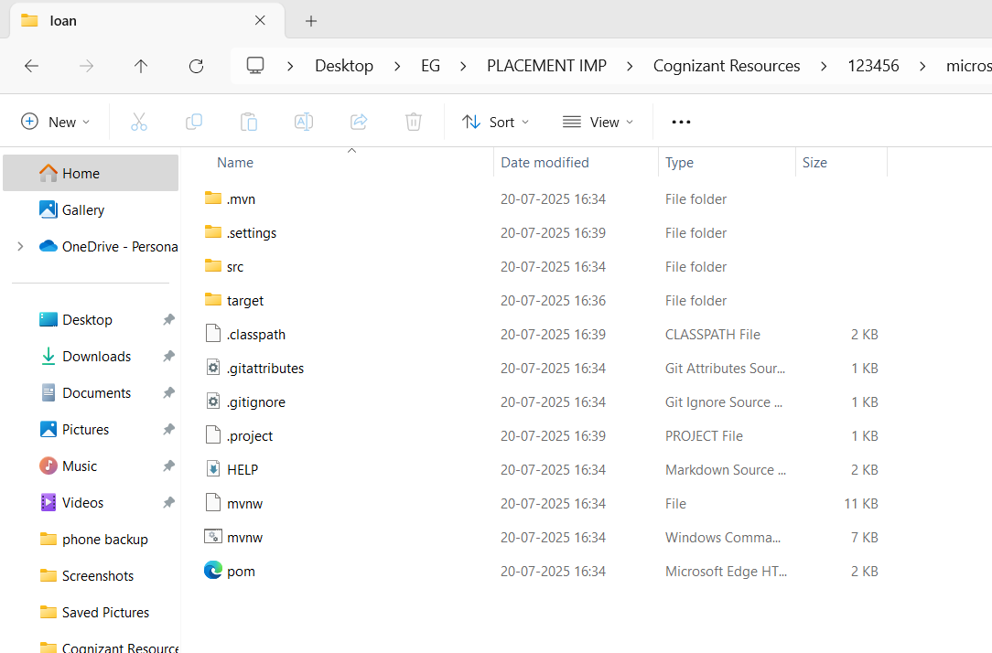

**Microservices for account:**

**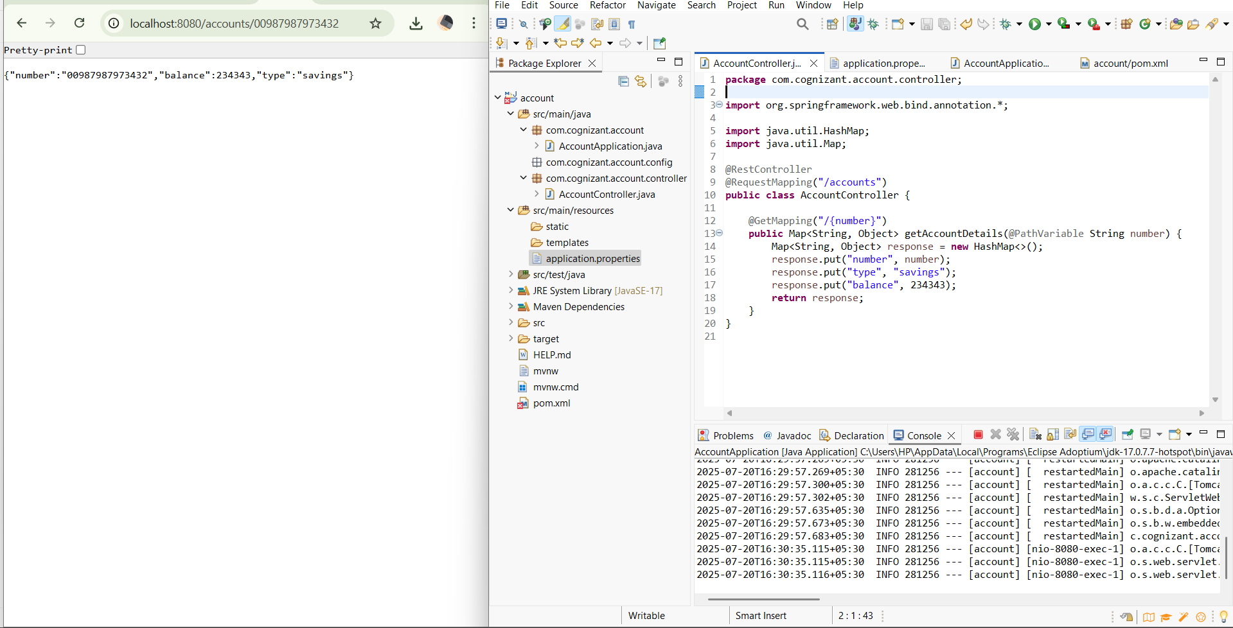  
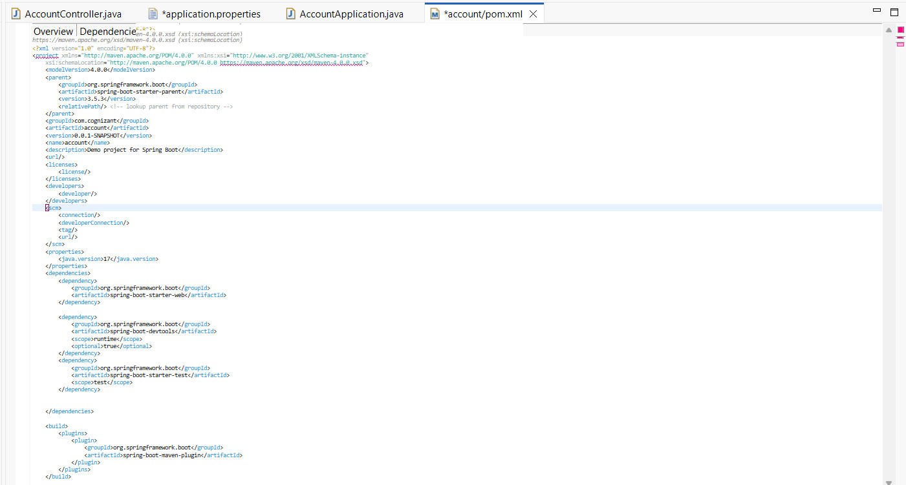  
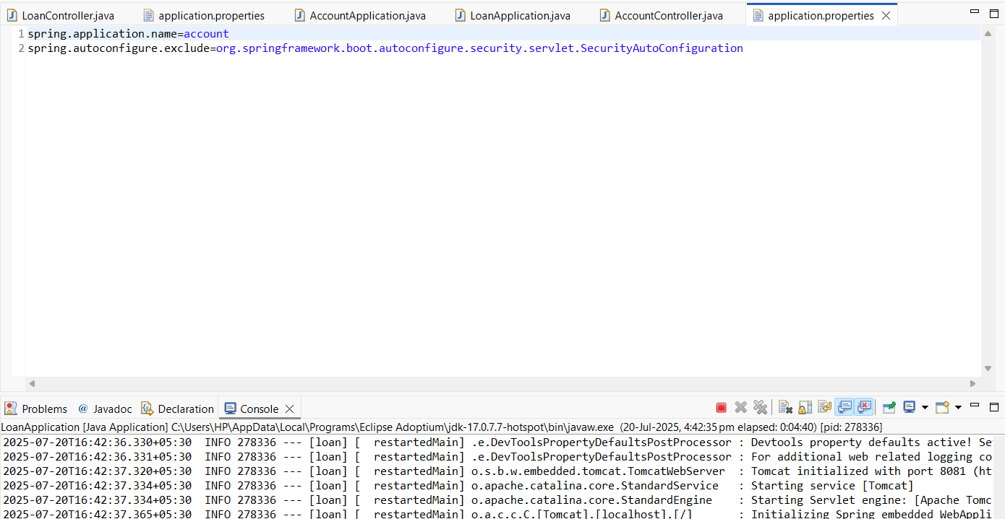**

**Microservices for loan:**

